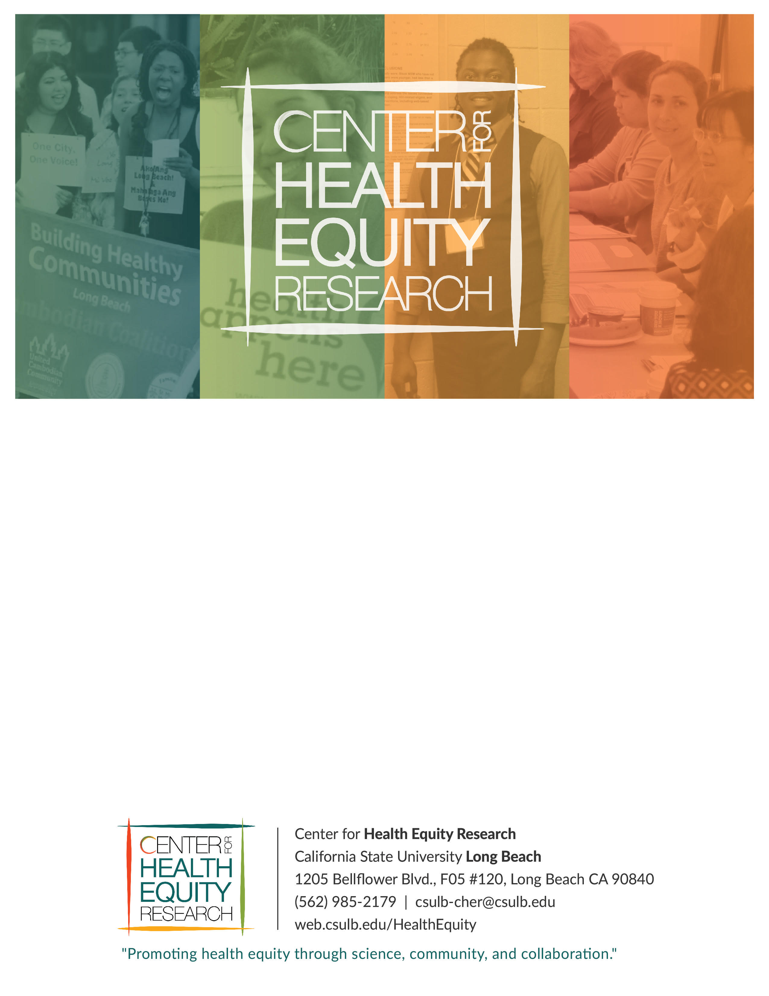
Center for Health Equity Research
California State University Long Beach
1250 Bellflower Blvd., FO5 #120, Long Beach CA 90840
(562) 985-2179 | csulb-cher@csulb.edu
web.csulb.edu/HealthEquity
My Sister’s Keeper
FINAL LOCAL EVALUATION REPORT
September 1, 2019 – December 31, 2021

Table of Contents
introduction 3
program description 5
About MSK Partners 9
Gems Uncovered 9
Long Beach Trauma Recovery Center (LBTRC) 9
Goodwill 9
Evaluation Activities 10
Evaluation Design 10
Development of Data Collection Instruments 12
Data Collection Activities 13
Data Analysis 14
Results 15
Long Beach Trauma Recovery Center 15
Gems Uncovered 16
Pre and Post Surveys 16
Participant Interviews 27
Conclusion 36
Bibliography 38

INTRODUCTION

Globally, human trafficking generates $32 Billion a year in profit. In the United States, California is one of the top four destinations to buy and sell women and girls (1). Eighty percent of reported human trafficking cases in California occurred in the San Francisco Bay Area, Los Angeles County, and San Diego County (2). These three areas of the country experience more human trafficking than anywhere else in the United States (2).
Long Beach, California is home to just over 460,000 residents (3) and is the seventh largest city in California at 52 square miles. The city has grappled with gang violence since the 1940s and is one of the most gang-impacted cities in the state (4). In the past decade, Long Beach has experienced an increase in human trafficking cases, in part due to an increase in gang involvement in human trafficking (4). Long Beach has approximately 6,000 known gang members and 60 active gangs (4). In 2014, gang membership in the city was 12.82/1,000 people, more than twice the state average of 6.18/1,000 people (4). The city’s gangs continue to drive violent crime rates in Long Beach (585.39 crimes/offenses/arrests per 100,000) which are exponentially higher than the State (425.7 per 100,000) and national averages (386.88 per 100,000)(5). Long Beach is located along the Pacific Coast, making this area a high target destination for thousands of domestic and foreign national traffickers each year due to easy access to the California-Mexico border and the Port of Long Beach, the diverse communities in the highest-density region in the country, and existing ties to gang-related activity(6).
Although gangs have historically trafficked drugs to earn money, the trafficking of young women is becoming more prevalent. According to the Long Beach Police Department (LBPD), each victim can generate up to $300,000 annually for the gang (7). In 2013, LBPD filed more human trafficking cases than any other agency in Los Angeles County (7). LBPD has reported that the majority of human traffickers in the city are gang members. In 2014, LBPD reported 17 human trafficking cases, 10 of which were gang-related. In just eight months during 2015, 91 arrests were made by LBPD – 20 sex trafficking arrests, 8 pimping arrests, 24 assisting prostitute arrests, 29 “John” program arrests, and 10 arrests for internet crimes against children (4). Beyond that, 22 minors between the ages of 12 and 17 were rescued, and 54 women were referred to resources and support services (7). In 2017, 11 human trafficking cases were filed, 14 minors recovered, and 54 adults were referred to services (7).
Long Beach is in a new era and the increasing human trafficking cases call for a multi-prong approach to address gang violence and gang victimization. The City of Long Beach has been the recipient of the California Gang Reduction, Intervention, and Prevention (CalGRIP) initiative since 2008. Its most recent award, CalGRIP 7 or My Sister’s Keeper, was a 3-year project that aimed to: 1) prevent human trafficking and decrease the number of trafficked girls and young women through outreach and awareness, and 2) decrease human trafficking cases in Long Beach through the arrest and prosecution of gang members involved in human trafficking. The program is a collaboration between the Long Beach Department of Health and Human Services, LBPD, City Prosecutor’s Office, and community-based organizations working together to support human trafficking survivors using a wraparound approach, while ensuring that those engaged in human trafficking are brought to justice.
Since 2015, the City of Long Beach Department of Health and Human Services (LBDHHS) has provided a network of services to meet the critical needs of gang-involved human trafficking victims via the “My Sister’s Keeper” (MSK) program. MSK program provides coordinated services focused on reducing gang membership, gang victimization, and sex and labor trafficking among at-risk youth (majority of whom are female) ages 10-24. The program has been supported by two state-funded grants: 1) the California Board of State and Community Corrections’ Gang Reduction, Intervention & Prevention (CalGRIP) program and 2) the California Office of Emergency Services’ Victims of Crime Act (VOCA) Fund Innovative Responses to Marginalized Victims. The evaluation of CalGRIP 7 by the Center for Health Equity Research at California State University, Long Beach found gaps in services, which were addressed by additional funding from the Department of Justice Office of Victims of Crime (OVC). With support from OVC, My Sister’s Keeper aimed to better serve victims of human trafficking by enhancing the quantity and quality of services provided by the program. This was accomplished by expanding the scope, breadth, and depth of MSK’s public outreach component and by augmenting the existing program with new services that participants identified as lacking from the previous iteration. This report presents findings from the evaluation of the enhanced MSK program.

PROGRAM DESCRIPTION
As part of Long Beach’s violence prevention plan, My Sister’s Keeper (MSK) provides a trauma-informed approach to disrupting the criminal enterprise of human trafficking by gangs or gang members. MSK program goals are to: 1) prevent human trafficking and decrease the number of trafficked persons through prevention and intervention activities, and 2) decrease human trafficking cases in Long Beach through the arrest and prosecution of gang members involved in human trafficking. MSK is implemented by the LBDHHS through a multi-sectorial network of partners and community-based organizations, and utilizes an evidence-based U.S. Department of Justice (DOJ)-supported, anti-human trafficking and anti-gang strategy via a 3-pronged approach: 1) citywide prevention, 2) intervention and 3) suppression. Specific activities within each prong are listed below:
Citywide prevention – Led by LBDHHS, citywide prevention includes a multi-media campaign and an annual symposiums with guest speakers who promote protective factors and raise awareness around risk factors. Prevention activities are directed toward at-risk female youth and their guardians, professionals who work with at-risk gang members and gang-victimized youth, and the community as a whole.
Intervention – Intervention activities are part of the city’s Directed Services Program (DSP), a court diversion program that is jointly operated by The Long Beach City Prosecutor's Office (City Prosecutor) and the Long Beach Police Department (LBPD). The DSP is designed to assist women engaged in prostitution-related offenses who were likely victims of sex trafficking. Human trafficking victims are given the opportunity to enter a one-year deferred entry of judgement process where their sentencing/dismissal is continued for one year. If the program participant completes the terms of the program, including accepting the full range of comprehensive supportive services provided by MSK community partners, the City Prosecutor will dismiss their case at sentencing. These services include trauma counseling, mentoring, and job skills development. Program participants receive a referral to a network of service providers if they require additional services not offered by MSK partners. These services include, but are not limited to, legal counseling, tattoo removal, and housing.
Suppression – Suppression activities are led by LBPD and includes sting operations, during which victims of human trafficking are rescued and provided with legal counsel at their first court appearance, during which they are asked to identify their trafficker. Once identified, perpetrators are arrested and charged.
Program eligibility: To participate in the MSK program, individuals must be: 1) victims of sex or labor trafficking, and 2) over the age of 18 years. While individuals who were identified by LBPD during sting operations must agree to enroll in the DSP in order to have their cases dismissed, DSP enrollment is not a requirement for MSK, as the program accepts walk-ins and referrals outside the court system. Please refer to Appendix A for a MSK program flowchart.
MSK Services
MSK services (Table 1) are provided by a network of partners working collaboratively to help human trafficking victims regain their freedom. The program utilizes evidence-based practices (EBPs) and strategies to implement its activities. The specific EBPs utilized by the OVC-funded program include wraparound case management, an awareness campaign, mental health treatment, and mentorship. The table below presents a description of the EBPs and strategies.

Table 1. My Sister’s Keeper program services
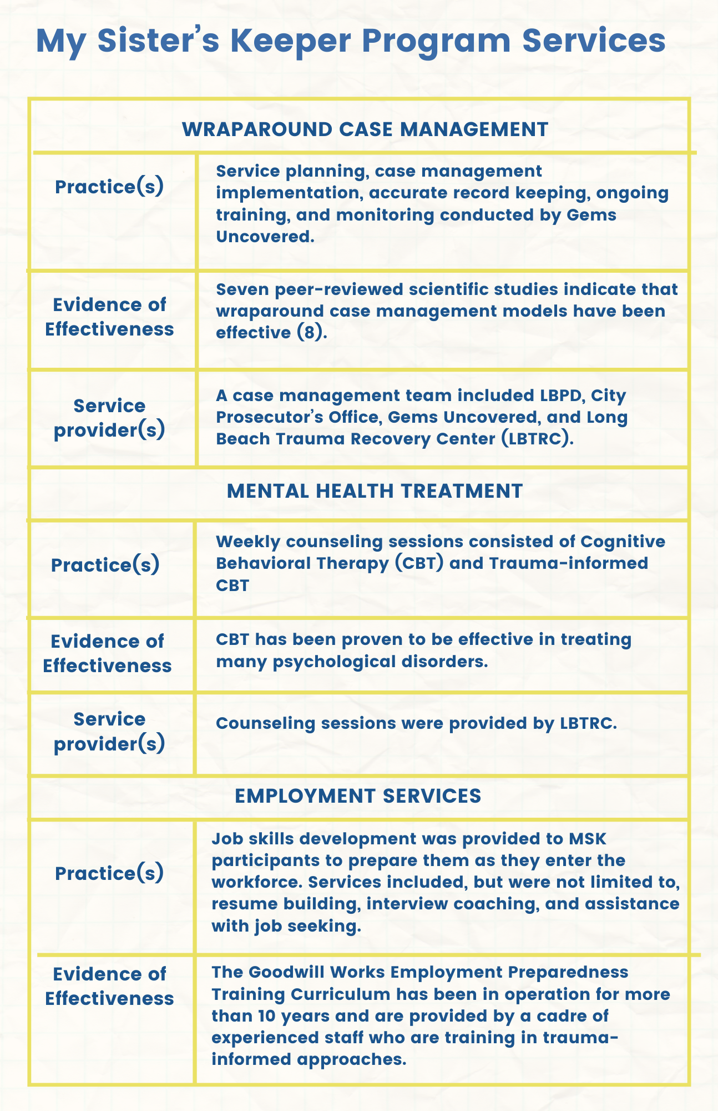
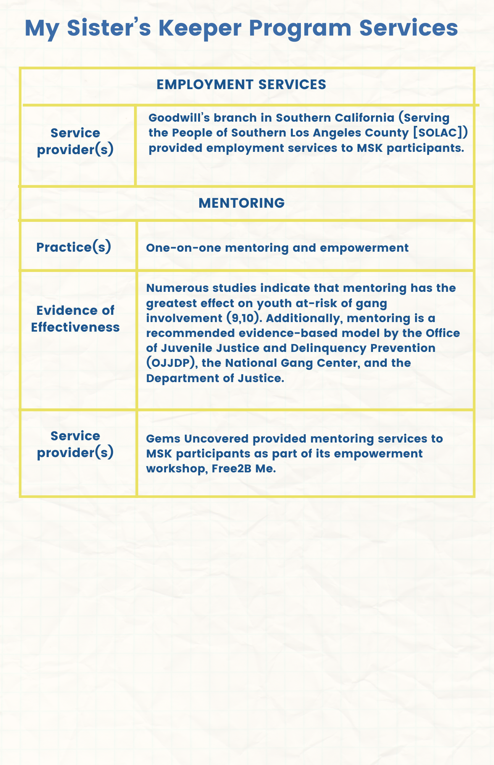
ABOUT MSK PARTNERS

Gems Uncovered

Established in July 2011, Gems Uncovered (Gems) is a community-based organization fighting against human trafficking with a focus on prevention and recovery support services. Gems conducts outreach every Friday night from 10 p.m. to midnight on the streets of Long Beach, Compton, and Los Angeles. A drop-in center that provides a safe place for young girls and women to heal emotionally and psychologically. As an MSK partner, Gems provides wraparound case management to program participants and offers an empowerment workshop provides victims with the opportunity to participate in the Free 2B Me sexual exploitation diversion program. Gems educates and empowers survivors of commercial sexual exploitation and trafficking provides victims with resources and referrals for medical services, mental health services, employment services, tattoo removal, victim advocacy services, and compensation claims.

Long Beach Trauma Recovery Center (LBTCR)
California State University, Long Beach’s LBTRC opened in April, 2014 and provides a comprehensive model of trauma and mental health care for victims of crime and their families, while removing barriers to care for underserved victims of crime. Approximately 25 participants per year are referred to LBTRC by the MSK program. LBTRC provides MSK participants with evidence-based mental health services to victims and their families, social services and physical health navigation, assistance with crime victim compensation documentation, and facilitating client cooperation with prosecutors. Services are provided by multi-disciplinary staff that includes psychologists, Licensed Clinical Social Workers, and psychiatrists that have specialized training to work with human trafficking populations.
Goodwill Industries

Goodwill Industries was established in 1929 and is dedicated to serving and empowering individuals who are disadvantaged and yet have the desire to go to work. Goodwill’s branch in Southern California (Serving the People of Southern Los Angeles County, SOLAC) seeks to transform lives through the power of work. Long Beach-based Goodwill is a nonprofit corporation that has worked to address the unique employment needs of victims through its evidence-based Goodwill Works Employment Preparedness Training Curriculum. Professionals in the workforce development program assist individuals with barriers to employment access and job retention, with the goal of achieving economic self-sufficiency.

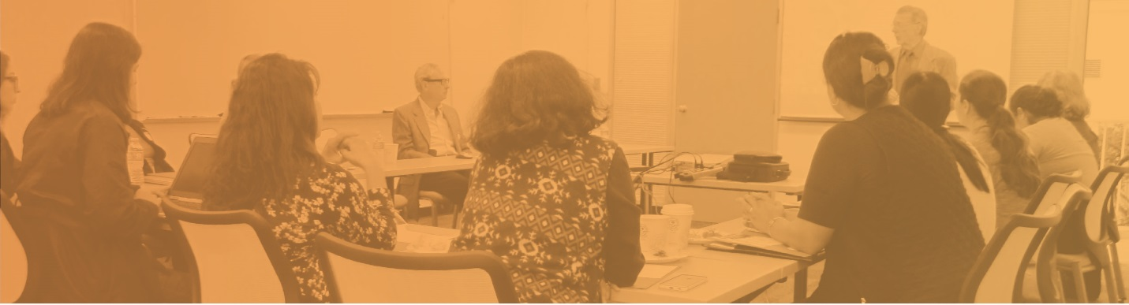

EVALUATION ACTIVITIES

The evaluation of My Sister’s Keeper was conducted by the California State University, Long Beach (CSULB) Center for Health Equity Research (CHER). Evaluation design and the development of data collection instruments were a collaborative and iterative process between the evaluation team at CHER, the MSK Coordinator, and MSK partner agencies.

About the Center for Health Equity Research
Formerly The Center for Health Care Innovation, CHER was established in 2013 with support from the National Institute on Minority Health and Health Disparities (NIMHD) Research Infrastructure in Minority Institutions (RIMI) grant to better reflect the focus of its work. CHER is located in the College of Health and Human Services at CSULB, an institution with a diverse student body and faculty with extensive research interests and expertise. The Center’s mission of “promoting health equity through science, community and collaboration” is reflected throughout its work to eliminate health inequities among residents in Long Beach. CHER was funded by the Substance Abuse and Mental Health Services Administration (SAMHSA) to implement PPOWER (Peer Promotion of Wellness and Enhanced Linkage to Resources), a community-based participatory research project that aims to prevent HIV and Hepatitis C infection, and substance abuse among young Black men who have sex with men (MSMs) through peer-to-peer outreach and education. In addition to My Sister’s Keeper, CHER currently serves as the evaluator for four other projects. They include: 1) Building Healthy Communities Long Beach (BHCLB), a 10-year place-based initiative funded by The California Endowment to improve community health in Central and West Long Beach; 2) The Community Wellness Program, a project funded by the California Department of Public Health (CDPH) Office of Health Equity to reduce mental health disparities among Cambodians in Long Beach and Santa Ana, 3) the A.I.R.E. Initiative, implemented by St. Mary Medical Center and funded by CDPH through its California Tobacco Control Program (CTCP) to reduce exposure to secondhand smoke through support of tobacco control policies; and 4) the Tobacco Education and Prevention Program, also implemented by LBDHHS and funded by CDPH CTCP to provide community education and technical assistance in tobacco control work.
Evaluation Design
The evaluation of My Sister’s Keeper follows a mixed method approach and was developed to assess intervention activities only (i.e., Prong #2). Data collection activities (Table 2) were designed to examine how participation in the MSK program contributed to changes in mental health, job-seeking skills, and ability to deal with everyday problems. Data collection activities were also designed to learn about the successes and challenges of service delivery and service utilization, as well as the barriers to service utilization among participants. These data helped inform the MSK team of providers of any adjustments that need to be made to ensure that the program achieves its intended outcomes. Whenever possible, data were collected by trusted program staff due to the relationships that they have established with program participants.
Table 2. Evaluation activities by service
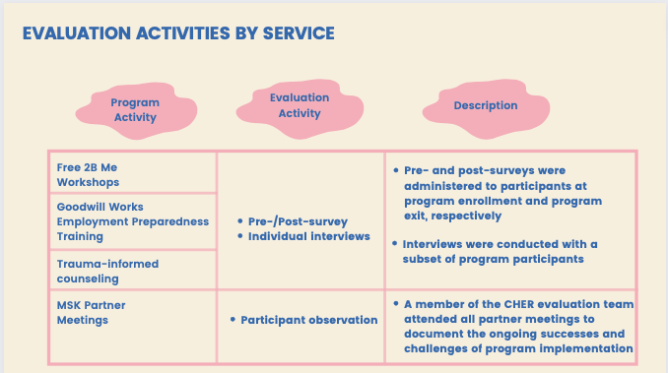
Process Evaluation
The CHER evaluation team attended all MSK partner meetings, both in person prior to the pandemic and via Zoom, to learn about successes and challenges related to the referral process, participant engagement, and service delivery from MSK partners. At each meeting, the evaluation team paid particular attention to the following information:

- Services rendered
- Number of participants served
- Accomplishments/Highlights
- Challenges encountered
- Barriers to service delivery and participant engagement
- Resources needed, including training and technical assistance

To supplement information gathered at quarterly partner meetings, the process evaluation also included reviewing partner reports to glean data on the successes and challenges to service delivery.

Outcome Evaluation
The following are outcome measures for activities implemented as part of the Intervention prong.
- Mental health
- Job-seeking skills
- Ability to deal with everyday problems

Modifications to the Evaluation Plan
The COVID-19 pandemic had a profound impact on program implementation and evaluation activities. All in-person program services and activities, such as the Free2B Me Workshops at Gems Uncovered, were held virtually via Zoom beginning in March 2020 due to the shelter-in-place order. Additionally, all in-person city-wide prevention activities (e.g., symposiums and community outreach) were suspended during the pandemic and as such, the evaluation team was not able to collect any data on city-wide prevention activities. Similarly, all pre- and post-surveys were staff-administered over the phone using an online survey that CHER developed to record participants’ responses. The online survey was originally designed to be self-administered, but after several failed attempts at getting participants to complete the surveys, the evaluation team switched to staff-administered phone surveys instead.
A large majority of MSK participants were referred to the program by the City Prosecutor’s Office as part of DSP. During the pandemic, sting operations by LBPD were placed on hold so as to not overwhelm the court system. Without LBPD sting operations, fewer individuals enrolled in MSK, which significantly impacted the number of participants who took part in the evaluation. As such, the evaluation team had to reduce its sample size for the pre- and post-survey. Other modifications to the evaluation included switching to in-depth interviews due to difficulties in finding a time that worked for everyone, as would be required for focus groups. Program participants also preferred sharing their experience in MSK one-on-one with an evaluation team member rather than in a group setting. All modifications to evaluation activities were submitted to and approved by the CSULB IRB.

Development of Data Collection Instruments
The development of data collection instruments was an iterative process. CHER staff developed all data collection tools and circulated MSK partner agencies to review and provide feedback. Below is a list of the data collection instruments that were developed for the evaluation of the MSK program along with a description of each instrument:
Pre- and Post-survey. CHER staff developed a pre- and post-survey to examine how participation in MSK contributes to changes in mental and emotional health, ability to deal with everyday problems, and confidence in joining the workforce. To develop the pre- and post-survey, the CHER evaluation team conducted a careful review of the services provided by MSK partners. The pre-survey contained 14 closed-ended questions (Appendix B) and the post-survey contained 10 items (Appendix C), including 2 open-ended question to allow participants to comment on their experience in the program. Both the pre- and post-survey took approximately 10-15 minutes to complete.
Interview guide. The CHER evaluation team conducted interviews with a subset of MSK participants to explore some of the key components in the pre- and post-survey and to learn about participants’ experience in the enhanced version of the program. An interview guide was developed with 8 open-ended questions to delve deeper into each of the program outcomes in order to learn how participation in MSK activities and services contributed to changes in mental and emotional health, ability to deal with problems, and confidence in joining the workforce. The interview guide also included questions that asked for feedback about the program overall, such as what members liked and did not like, and suggestions for improvement. Interviews took approximately 30 minutes to complete.
Data Collection Activities
All CHER evaluation team members, CHER interns, and program staff who helped with evaluation activities were required to complete an online training on Human Subjects Research provided by the Collaborative Institutional Training Initiative (CITI) program. This training serves to ensure that IRB guidelines surrounding voluntary participation, informed consent, and confidentiality are followed during the design of evaluation activities and the data collection process.
Participants were invited to participate in the evaluation upon enrollment in the MSK program. If they agreed participate, they were given a pre-survey to complete on-site, along with program enrollment paperwork. The pre-surveys took approximately 10-15 minutes to complete, upon which participants received a $10 Target gift card. Post-surveys were completed at the end of the program (i.e., after participants completed services at Gems, Goodwill Industries, or LBTRC) during a meeting with partner staff to complete exit paperwork. The post-survey took approximately 15-20 minutes to complete, as it included two open-ended questions. Participants also received a $10 Target gift card for completing the post-survey.

To adhere to COVID-19 safety guidelines during the height of the COVID-19 pandemic, all in-person activities were suspended, including survey administration. Instead, staff administered pre- and post-surveys via telephone and used an online survey to record participants’ responses. This was the preferred method of data collection after several failed attempts at asking program participants to complete the online surveys on their own. Reasons for not completing surveys included: forgetting to complete the survey, not receiving a link to the online survey, not being able to navigate the online survey, and not having a mobile device to complete the survey. Gift card incentives were either mailed to participants to an address they provided or were available for pick up at the Gems Uncovered office.

Data Analysis
Quantitative data were entered by members of the evaluation team and trained student interns and analyzed using SPSS Version 22. Univariate analyses were performed on all variables to examine frequency and distribution.
The CHER evaluation team conducted a careful review of qualitative data from individual interviews with program participants, during which key themes were noted. The evaluation team then performed data triangulation, such that data from interviews were used to verify and support results from the pre- and post-survey. During the qualitative data review process, the CHER evaluation team also noted any additional themes that emerged that were not explored on the survey. Lastly, the evaluation team reviewed the list of identified themes that emerged during interviews and selected quotes that best highlighted each theme.

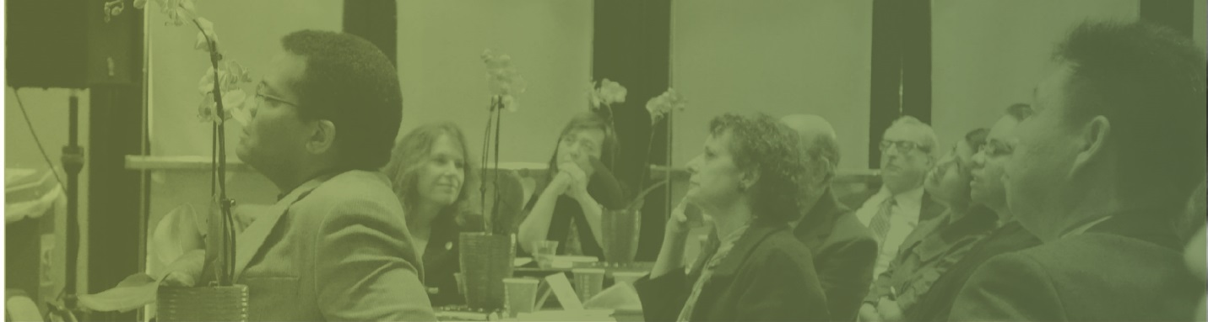

RESULTS

The following section of the report presents evaluation data from pre- and post-surveys and participant interviews. Also included are process level data gleaned from individual MSK partner reports.
Long Beach Trauma Recovery Center
The Long Beach Trauma Recovery Center (LBTRC) served a total of 40 clients from 2019 to 2021, 15 in 2019, 9 in 2020, and 16 in 2021 (6 clients were pending enrollment during the writing of this report). As previously described, the COVID-19 pandemic had a significant impact on enrollment, as LBPD suspended its sting operations, which was the main source of participant referrals to the MSK program. Nevertheless, the MSK program had a profound impact on participants, as is highlighted by the story shared by LBTRC:
Sabrina is a female aged 22, who identifies as African American and completed 12 sessions at LBTRC. She came in to center through My Sisters Keeper. She was picked up by undercover agents and charged with prostitution. She began therapy to help her through her healing journey and to get her prostitution charged dismissed. Sabrina came in not very willing to share her story and would give very vague answers during the first few sessions. After a conversation with the therapist, she began engaging and being more present and responsive. Sabrina and her therapist discussed childhood traumas that affected her cognitions and how she saw the world around her. Sabrina would often state, “The world is just not safe for a person like me, so I have to do, what I have to do to take care of myself.” Sabrina engaged in an evidence-based therapy called Narrative Exposure Therapy (NET), in which clients write out their narratives based on the traumas that they have experienced. NET is unique in pointing out the “flowers” in someone’s life, which are times of happiness or validation. Sabrina completed her timeline and was always proactive in her healing. At the last session, Sabrina wrote an “I am Poem” in which she stated, “I come from a line of strong women, but I have broken the chain and have taken the steps to heal.” She came in very depressed. We chose to do NET, since she had complex traumas and various occasions of trauma throughout her life that she wanted to discuss. We incorporated grounding techniques and the use of meditation. She utilized these coping skills outside of the therapy office and shared that they helped reduce her intrusive thoughts and reduce her anxiety. Sabrina reported after her last session that she was still motivated to seek long term therapy and would continue to empower herself and take care of herself. Due to her efforts and self-motivation, her story and process was a success!
Gems Uncovered
Gems Uncovered enrolled a total of 70 clients between 2019 and 2021, 26 in 2019, 27 in 2020, and 17 in 2021. Due to the COVID-19 pandemic and the subsequent shelter-in-place order, workshops and case management was delivered via Zoom beginning in March 2020. However, despite this transition, Gems Uncovered was successful in keeping participants engaged in program services, and in helping participants achieve their goals.
Our client, Nancy, came into the program with no expectations. However, she shared that she was committed to coming to sit and just listen. Nancy and her baby lived in a motel and each week, according to her, she saw herself wanting to change because of what she was learning from our workshops, the connection that she was making with other participants, and the people that presented her with life-changing options, such as job opportunities. The gift card incentives that she received from MSK allowed her to give her son his 1st birthday party and buy necessities. The weekly lessons helped her understand more about her trauma, which started when she was only 13 years of age. She took advantage of all of the options presented to her in the MSK program and after 2 years of living in a motel, she and her son now have an apartment. She works for California COVID-19 Rent Relief, which she says she enjoys because she is sharing information with people and is making a difference in their living situation, and that makes her feel like she's helping others.

Pre- and Post-surveys
Thirty-two (32) participants enrolled in the evaluation and completed a pre-survey. Due to program attrition, only 24 participants completed a post-survey and were included in the analysis. All participants in the sample were female with a mean age of 24.8 years, ranging from 18 to 33 years (Figure 1). The two largest racial/ethnic groups were African American/Black (50%) and Hispanic/Latino (50%). One-third (33.3%) of participants did not complete high school, 29.2% had a high school diploma or GED, and 20.8% attended college, but did not graduate with a degree.

Figure 1. Demographic characteristics of MSK participants, n=24
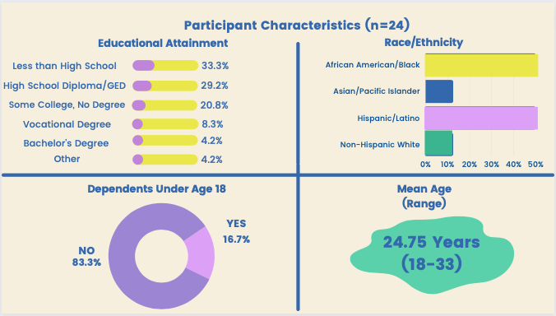
Although the MSK program and services are based in Long Beach, California, almost 70% of participants lived outside of Long Beach (Figure 2). One participant lived in Hemet, almost 100 miles away.

Figure 2. Participants’ current living situation
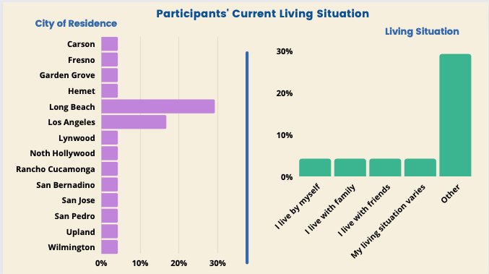
Over half of participants reported that they lived with family/relatives (37.5%) or friends (16.7%) (Figure 2). One-fifth of participants reported unstable housing, such that their living situation varied from time to time. Almost 20% of participants have a dependent under the age of 18 years in their care (Figure 1).

MSK offers a variety of services to assist in the successful transition out of “the lifestyle” for its participants, including wraparound case management, trauma-informed counseling, and job skills development. Upon joining the program, participants were asked about the services that they needed most and upon program exit, they were asked to select from a list the services they utilized while in the program (Figure 3). At pre-survey, the most commonly-identified service included job placement/job skills development (54.2%), housing (45.8%), healthcare services (37.5%) and legal services/record expungement (33.3%). At post-survey, 45.8% of participants reported receiving job placement/skills development assistance and an equal percentage of participants utilized counseling services. Approximately 21% of participants utilized legal services, and 16.7% received housing assistance.

Figure 3. Services needed by MSK participants vs services received
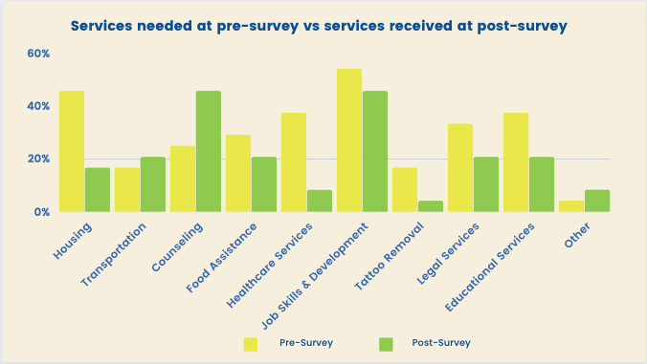

Figure 4. Difficulty accessing MSK services by participants, n=24
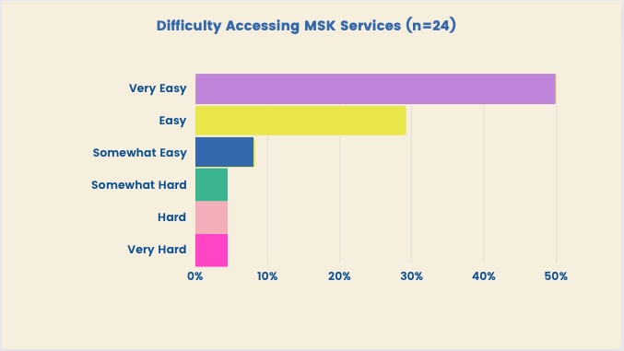

Despite 70% of participants living outside of Long Beach, almost 80% of participants found access to MSK services easy (29.2%) or very easy (50.0%) (Figure 4).

Program Outcomes
The pre- and post-survey was designed to assess changes in the program outcomes, which include ability to deal with problems, emotional/mental health, and job-seeking skills. We analyzed survey data to evaluate the MSK’s progress towards achieving the intended outcomes.

Ability to Deal with Problems
Participant’s perceptions about being able to deal with their problems were assessed by their level of agreement to the following statements: “I can deal with my daily problems”, “I can take control of my life”, “I can take care of my needs”, and “I can handle things when they go wrong”. Compared to pre-survey data, fewer participants at post-survey agreed or strongly agreed that they were able to deal with daily problems (Figure 5).

Figure 5. I Can Deal with My Daily Problems/I can take control of my life
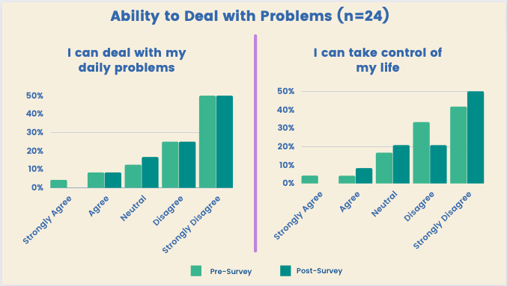
At post-survey, the percentage of participants who agreed or strongly agreed that they were able to take control of their life remained unchanged (Figure 5). However, fewer participants disagreed or strongly disagreed with this statement at post-survey, indicating some improvement in this area.
The largest improvement was observed in participants’ ability to take care of their needs (Figure 6). At post-survey, 16.7% of participants agreed or strongly agreed that they are able to take care of needs as they arise, compared to 8.4% of participants at pre-survey.

Figure 6. I Can Take Care of My Needs/I can handle things when they go wrong
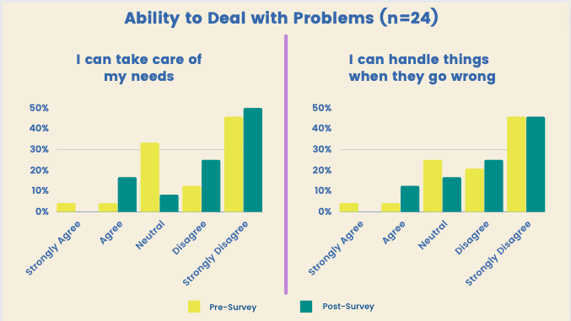
An improvement was also observed in participants’ ability to handle things when they go wrong (Figure 6). At post-survey, 12.5% of participants agreed with this statement, compared to 8.4% at pre-survey.

Emotional/Mental Health
Participant’s emotional/mental health was assessed by asking participants to indicate how often, in the past week, did they feel nervous, hopeless, restless or fidgety, depressed, worthless, and that everything was an effort. At post-survey, slightly more participants reported feeling nervous most of the time or all of the time (16.7%), compared to pre-survey (12.5%) (Figure 7). It is important to note, however, that more participants reported not experiencing nervousness at all at post-survey (37.5%), compared to pre-survey (29.2%), indicating an improvement in this area.

Figure 7. How Often During the Past Week Did You Feel Nervous/Hopeless?
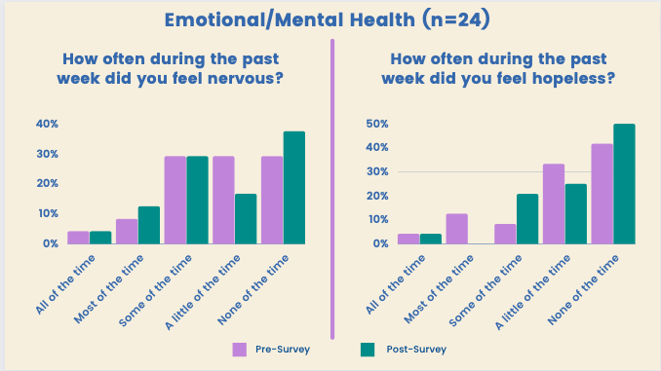
At post-survey, 4.2% of participants reported feeling hopeless most of the time or all of the time, compared to 16.7% at pre-survey, and half of participants reported not feeling hopeless at all in the past week, compared to 41.7% of participants who reported the same at pre-survey (Figure 7).
Fewer participants at post-survey reported feeling restless or fidgety most of the time or all of the time during the past week (16.7%), compared to participants who reported the same at pre-survey (25%), and almost 46% of participants reported no feeling restless or fidgety at all during the past week at post-survey, compared to one-third of participants who reported the same at pre-survey (Figure 8).

Figure 8. How Often During the Past Week Did You Feel Restless or Fidgety/Depressed?
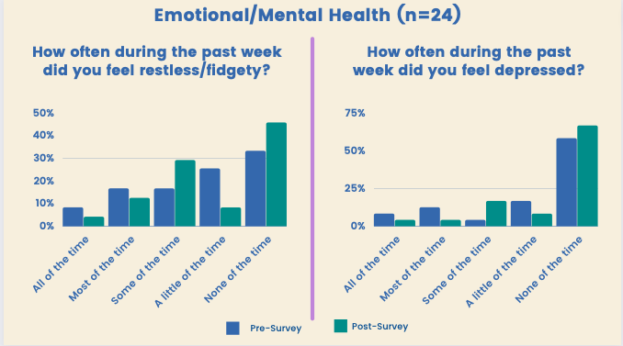
At post-survey, 8.4% of participants reported feeling depressed most of the time or all of the time, compared to over 20% of participants who reported the same at pre-survey. Two-thirds of participants reported not feeling depressed at all at post-survey (Figure 8).
Fewer participants at post-survey reported feeling that everything was an effort most of the time or all of the time (12.5%), compared to those at pre-survey who reported the same (29.2%). Almost twice as many participants reported never feeling that everything was an effort (50%), compared to those who reported the same at pre-survey (25.5%) (Figure 9).

Figure 9. How Often During the Past Week Did You Feel That Everything Was an Effort/Worthless?
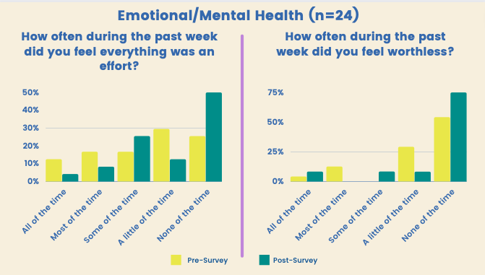
At post-survey, fewer participants reported feeling worthless most of the time or all of the time during the past week (8.3%), compared to 16.7% at pre-survey. Three-quarters of participants reported not feeling worthless at all at post-survey, compared to 54.2% at pre-survey (Figure 9).
Job-seeking Skills
To examine how participation in the MSK program contributed to changes in job-seeking skills, participant were asked to indicate their level of agreement to the following statements: I am able to look for a job on my own, I feel confident that I can apply for a job on my own, I know how to write a resume, and I am confident I can perform well during an interview. No change was observed between pre- and post-survey in participants who agreed or strongly agreed that they were able look for a job on their own (Figure 10).

Figure 10. I am Able to look for a Job on My Own
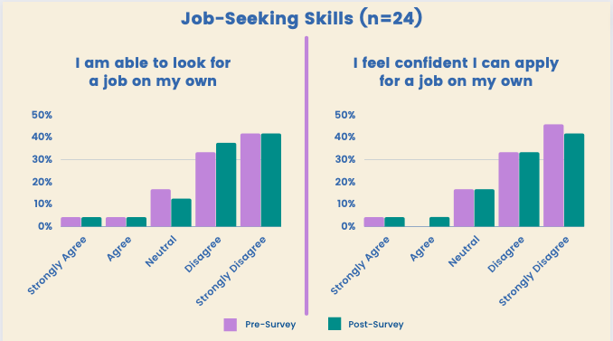
A slight improvement was observed in participants’ ability to apply for a job, such that 8.4% of participants agreed or strongly agreed with this statement at post-survey, compared to 4.2% at pre-survey, and fewer participants disagreed or strongly disagreed with this statement at post-survey (79.2%), compared to those who reported the same at pre-survey (75%) (Figure 10).
Interestingly, fewer participants at post-survey (4.2%) agreed or strongly agreed that they knew how to write a resume, compared to participants who reported the same at pre-survey (12.5%). However, fewer participants at post-survey disagreed or strongly disagreed with this statement (58.4%), compared to participants who reported the same at pre-survey (66.7%), indicating an improvement in this area (Figure 11).

Figure 11. I Know How to Write a Resume
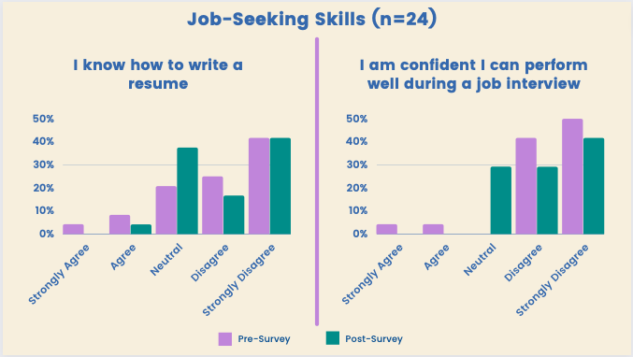
When asked about how well they can perform during a job interview, none of the participants at post-survey agreed or strongly agreed with this statement, compared to 8.4% of participants at pre-survey who agreed or strongly agreed. While this finding may indicate that participants reported less confidence at post-survey, data show that 70.9% of participants at post-survey disagreed or strongly disagreed with this statement, compared to 91.7% of participants at pre-survey who reported the same, thereby indicating an improvement of over 20 percentage points (Figure 11).
Survey data revealed the progress MSK has made towards reaching program goals and objectives, as improvements have been reported among participants’ ability to deal with their problems, emotional/mental health, and job skills. Overall, the number of participants who strongly disagreed with being able to deal with their problems decreased after completing the program. Similarly, there were noticeable improvements in all areas related to participant’s mental/emotional health before and after the program. Although there were no significant improvements among participant’s confidence in job skills after completing the program, there was a slight decrease among those who strongly disagreed in having confidence all areas related to job skills.

Participant Interviews
CHER staff conducted a total of 9 interviews with a subset of MSK participants between September 2020 and July 2021 a total of nine interviews were conducted by CHER staff in order to learn about their opinions and perspectives about the program and how it has impacted them. In response to the COVID-19 pandemic and in the interest of maintaining participant confidentiality, interviews were conducted either over the phone or via Zoom. Interviews averaged approximately twenty minutes in length.
Figure 12. Interview participant demographic characteristics, n=9
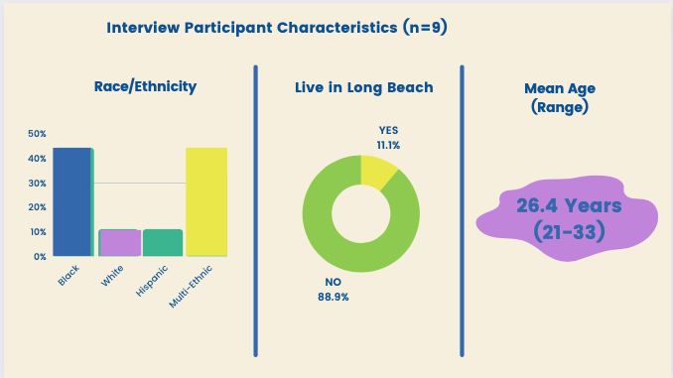
Participant characteristics are presented in Table 22. All interviewees were female and the average age was 26.4 years, ranging from 21 to 33 years. Almost 90% of interview participants did not live in Long Beach. The racial/ethnic backgrounds among interviewees were diverse, with four reporting they identify as Black, three as multi-ethnic, one as White, and one as Hispanic.
Reasons for joining MSK – What aspects of the project interested them?
With additional funding from OVC, the My Sister’s Keeper (MSK) program aimed reduce the number of trafficked persons through intervention activities that are designed to positively impact the lives of human trafficking survivors. During their court hearing, individuals were given the option of enrolling in MSK as part of the Direct Services Program through the City Prosecutor’s Office. As part of the interview, we wanted to learn what interested participants most in joining MSK. Most participants stated that the primary reason for joining the program was because they had no choice and were court ordered or that they wanted to enroll so their cases are dismissed at sentencing. However, some participants shared that they looked forward to having someone that could help guide them. Others joined due to the variety of services that the program offered.

“What interested me was how much help they said they would give us. You know, like, so it for sure helped me a lot and helped me make the right choices. It kind of gave me a person that was like on me, you know, to do better and they wanted to see me do better and it felt good, it made me feel like I had someone.”

“They had different resources as towards help with schooling, job search, like tattoo removal and all that. I mean I didn’t do like most of them, but I just like the fact that they offer thing to help-you know, improve wherever in your life you need help with. So, yeah, I would say that.”

Experience in MSK
Services provided by MSK partners included job skills development, trauma-informed counseling, and empowerment workshops. If additional services are needed, MSK partners referred participants to a network of partners that provide tattoo removal, housing, and legal services. During the interview, participants were asked to share what they liked most about the services they received and about the program in its entirety. They were also asked to identify areas of the program that needed to be improved. Overall, participants shared a great appreciation for the support they received from program staff, but there were barriers that made it difficult for participants to access services, especially for those who did not live in Long Beach and lacked transportation.
“All of that was super helpful. I loved the feeling of the support groups in the GEMS Uncovered and it’s good information about habits and what happens with us psychologically. And then…yeah, the job search was great with Goodwill and yeah, trauma and therapy…yeah, it’s all good. It’s all good.”
“I guess I liked that they were on me. You know they would call me every week and you know make sure I was handling everything that I wanted to handle. I don’t know what I didn’t like to be honest. Oh, I guess it was kind of hard, it was kind of hard to like get there all the time. Sometimes if I were to have to go to certain places cause I don’t have a car. But then it would help me with the gift cards.”

Not all of the participants we interviewed were happy with their experience in the program. One participant shared that the program was far from helpful, but while she expressed her discontent with program staff, she valued the relationships she made with fellow participants, as the quote below demonstrates:

“As far as the My Sister’s Keeper program goes, honestly, they haven’t been doing smack for me. Nothing, but calling my phone and annoying me, that’s about it. What I like about the program is that I met other girls who went through the same stuff as me, from the same background, so in a way I knew and I felt like I wasn’t alone. I had a bigger mission in life than just selling my body. The thing that I don’t like about the program is how no one follows up about anything they say they’re going to do and then when they do follow up it’s, “Oh, you have to call and express this and say that”. No, I don’t have to call and say smack. Y’all have to know my situation when I joined the program. I shouldn’t have to call you every week to tell you what’s wrong. It’s to the point now that I don’t even wanna talk to them ‘cause, like, literally they give me a headache, they get my hopes up. ‘I think this is going to happen, I think that’s going to happen.’ It doesn’t happen.

One participant expressed that although program staff attempted to link her to the services she requested, there was a lack of understanding among program staff of her needs, particularly for housing.

“They were looking into stuff like that for me, but it was always the homeless shelters and they want me to stay. I already told them I’ve done that in my life and it didn’t work for me. I need my own place to stay, like I have money, I’m doing hair now, like I have a job I’m not selling myself no more, so I can pay rent. I just don’t think they understand that. So yeah, that’s just a headache. I just stopped dealing with them completely.”

Finally, one participant shared that although program staff wanted to help, the program was too short to be effective in helping human trafficking survivors to fully transition out of the lifestyle.

“What I liked the most is that everybody seemed legitimately honest and wanted to help, but the program was kind of short. For me, I did the 6-week program. I mean, with transitioning out of the lifestyle, it’s more than just… you know what I mean? It takes a long time to just get all the way completely out.”

Barriers to accessing the services
MSK participants were human trafficking survivors who relied on their traffickers for food, shelter, and transportation. As such, we wanted to learn about the barriers participants may have faced when accessing program services. We also wanted to learn how program staff contributed to capacity building among participants so that they can gain greater confidence and independence to access services on their own. Many participants voiced their appreciation for the ease of being able to contact program staff when they needed help.

“For GEMs, they are literally like always there, even if it’s a missed call they have to get back, the GEMs program was always there. I never had to worry about them.”

“Whenever I called Mary or Myra, and even Vericia, they always called me back almost immediately. Umm, and they were helpful whenever I asked for something or they suggested different things to me which was nice.”

“It was cool, I still feel like I would text them and let them know everything that’s going on in my life even though the program is over. Yeah, it was easy to get in contact with them ‘cause I had their numbers, so I would just text them and usually they call me and text me back right away.”

Of the nine participants we interviewed, only one individual lived in Long Beach and one lived as far away as North Hollywood, 40 miles from MSK partner offices. As the quotes below demonstrate, transportation was a significant barrier to program participation, but this was alleviated when meetings were held virtually in response to the COVID-19 pandemic.
“I had to walk to GEMS Uncovered and it wasn’t that bad, maybe like 35 minutes, but for somebody without a car, the Zoom meetings were really easy because anybody can do that from anywhere. But when it came time to meet in person, I loved doing it, but it wasn’t very easy.”

“Me personally, I think that it was—it was easy, but that’s because I have a car. I’m not sure—if I was on the bus like I was before, maybe it would’ve been harder ‘cause Long Beach is far.”

“The fact that it was on Zoom made it 100 times better ‘cause it’s literally online, you can do it from your phone. So, that’s—it was really easy.”

Feedback on project staff
Establishing a trusting relationship between program staff and participants is vital for participant engagement, and in helping them to successfully transition out of the “lifestyle”. Therefore, we asked participants to provide feedback on what it was like working with project staff (i.e., staff at MSK partner agencies). Most participants had a good experience with staff and stated how helpful everyone was during the program, as demonstrated by the quotes below.
“It was good, they were very compassionate, caring, and interactive. Other than that, they were good, very attentive. They just make sure we’re good, asking us questions, making sure everyone was included in everything.”

“I think the staff was great. There’s nothing that I would really add. They were all good listeners to figure out what each of us individually needed, so I think the fact that they were just really good listeners was like a plus.”

“Extremely helpful. Umm, we were one-on-one which was nice. In that aspect, it was helpful.”

Overall impact of MSK
The MSK program was designed to address the challenges that victims of human trafficking may face while trying to transition out of the lifestyle. Services offered by MSK aimed to improve mental health, increase job skills, and to empower participants to access additional services and resources on their own. During the interview, participants shared how their participation in the MSK contributed to improvements in their mental well-being, ability to take control of their life and handle problems, and confidence in seeking employment.
Mental well-being is an important part of the healing process for a successful transition for participants. When asked about how the program has contributed to changes in their mental well-being, participants shared that the program provided services that would have otherwise been out of reach for them. One participant shared her appreciation of trauma-informed counseling and how it helped increase her confidence to work on achieving their goals.
“Honestly, the counseling and everything, I really needed that. You know, I always wanted that, but I know it’s expensive. I went through a lot of stuff and honestly I’m just happy to go to the therapy sessions. I kind of was nervous about it, but I mean I know I need it. Even my whole family, like, they always wanted me in therapy, you know, so it’s kind of cool to me that I’m getting that done.”

“It definitely got me focused. I’m more motivated to do things and handle things in an ‘on time’ manner.”

“It’s helped a lot actually. Yes, umm, I feel more confident. I realize that this is life, not everyone has to experience this. Yes, it can happen and it does happen, but it doesn’t have to happen forever. We are able to rise above it, get an education and do something with ourselves—with myself.”

“It contributed a lot actually. I know before this program, I was really kind of stressed out and kind of at a dead end, you know what I mean? Trying to figure out what I can do and they kind of made me realize it’s realistic. You can be a part of the real world and not just fade in and out. It’s just realistic to have a regular life, you know?”

An overarching goal of the MSK program is to increase participants’ ability to take control of their life through the combination of services offered and linkage to additional resources. Therefore, we asked participants about how MSK has changed their ability to address problems as they arise. Two participants stated that they felt more confident to get things done and are more empowered to say ‘no’, while other participants shared that they mostly had things under control, but the program increased their ability to be more aware of things around them.
“I mean [the program] showed me that I can get things done. It showed me, like you know, it’s easy to access people that will help. You know, that no one should say they can’t get it done. There’s help out there.”

“I kind of already had control where I had a job and I have my own place. So, I mean, it went well as far as that. Like I mentioned before, just more so - more of a perspective and more social awareness.”

“It helped show me how to handle things in life. You can’t be procrastinating, it just won’t help. As well as taking control, as in knowing when to say ‘no’ in certain situations with people.”

“Oh yeah. Now, I’m more of a ‘no’ girl now instead of a ‘yes’ girl.”

Transitioning out of the lifestyle presents a variety of challenges for each individual. Despite participation in the MSK program, one participant stated that she still struggles with maintaining control of her life.

“Man, like 50/50. One minute I’m in control - one minute I’m not.”

Increasing participants’ jobs skills is a crucial step towards independence and contributes to a successful transition into the workforce. Most participants shared that job coaching was very helpful and greatly increased their confidence in their interview skills and their ability to search and apply for jobs that allow them to enter into their desired career of their choice.
“It helped me. It for sure did help me. It kind of made me – ‘cause I’m kind of like a quiet person, like kind of anxious and stuff, but I feel like they had me talk to a lot of people and just kind of get out my box.”

“Well yeah, they always encourage you to do other things. I mean, when I started with them, I was doing security and then after that I kind of got into life insurance and after that – now, I’m in my first day on the job as a medical assistant.”

“I would say it’s at least 50% better than what it was. They helped pretty much—I don’t know, we kind of did, like, re-enactments of what would they want and, you know, we went over it so it was more like you’re selling yourself, but you’re not overselling yourself, so it was kind of like a how-to on how to deal with people and not get overwhelmed and be okay with them doing background checks and not freaking out.”

“It’s helped me definitely with my job interview skills. Also, even knowing what to wear, what’s appropriate. I was able to ask Vericia what’s something I should wear that’s appropriate for different job positions and she explained to me a white top and black bottoms, which was nice. …She also is making me, forcing me almost, to get a GED, which I’m not in opposition to, I agree with her. But I like that. Vericia was able to explain to me how to—she was able to teach me rather—how to deliver…like as statements, in a positive light. So, even hard questions that are asked to all people in interviews, she explained me how to answer them gently.”

Lastly, we wanted to learn from participants about how they feel the program has contributed to their ability to access services and resources on their own, as MSK included capacity-building activities. Most participants stated that they feel the program has supplied them with all that they needed and that they do not need to reach out to outside resources for additional services. However, they shared that they did feel confident to access services on their own, if needed.
“Oh yeah, like with them helping me and stuff, it kind of gave me motivation to where I do my own research too and also, ‘cause I just feel motivated and really dedicated to change into where I’m at right now. So yeah, ‘cause I saw that there was change and I want to make more change.”

“Yeah, I think just the practice of getting in the rhythm of, like, setting appointments and yeah, just like the business mindset probably.”

“To be honest, with all of the help through the program, I haven’t really needed to do anything too much on my own. It’s worked out for me, I haven’t had to do too much of anything on my own, but pick up the phone and that’s about it, but yes, I do feel more confident to seek services on my own.”

Overall
Most participants shared that they had a positive experience with the program, and hope that others like them can also benefit from the program. Participants expressed gratitude for being able to participate in the program and to benefit from the services that were made available to them in an environment that embraced them, and with people that were accepting and compassionate.
“I mean, all I can say is that it’s the best program that you could ever go to. If you’re ever in the lifestyle or just you know caught up in it by being forced, so I would say that the program is very helpful. And I would say that they should include the therapy always.”

“I’m so glad it exists. I’m so glad this program exists to help people and to actually give like a holistic—I would say it’s a really well-rounded program that touches all of the needs that would come up emotionally, spiritually, yeah, physical needs, like I said about even clothing…job search. It’s really all-encompassing and it’s pretty awesome. It actually…GEMS Uncovered also helped me with housing too, so yeah. I think it’s pretty amazing what they do and I’m so glad they exist. This is so worth doing and it’s still worth doing.”

“It was a really great program. I wasn’t expecting to enjoy it as much as I did and to get anything out of it. You know? Most program, they help you for the time that you’re there and you don’t really get anything out of it, but I actually did, you know. It really felt like a comfortable program, a safe place to really, like, to fix my problems and I just felt not judged. Like, it wasn’t, you know, when you go into program and people are like, ‘Well, what are you here for?’ It kind of shakes them up a little bit and they kind of have a different outlook about you. I never once felt judged by anybody. Even when there was a male in one of the program settings or whatever that I went to talk to about help, he didn’t make me feel uncomfortable, he didn’t make me feel weird. It was really nice to be looked at on the face and not judging you know? Nobody judged me. It was a really good feeling.”

“I think it’s wonderful that there are people who do care even if they haven’t experienced the game or that they have empathy and they are willing to accept other people who experience traumas in life and embrace me—embrace us. And umm, thank you for your compassion and understanding and for allowing us to have a step forward. Helping us, rather, to take a step forward.”

“Umm…that if this program is offered to more people I would hope that they would take advantage of it because it’s a really good program. And sometimes when we are like, doing things that are new to us, we either don’t want to do it or we just have like a sucky attitude towards doing it, but I think if more, like, females were in the program and, like, stuck with it, they would really enjoy it because there’s a lot of knowledge and a lot of help that comes along with being in the program.”

CONCLUSIONS

Evaluation findings revealed the positive impacts that MSK had on participants’ mental health, job-seeking skills, and ability to deal with problems. Survey data showed that improvements were made in each of these areas. These findings were further corroborated by data from interviews with participants, many of whom shared their appreciation of program services and its caring staff. MSK provided the necessary capacity-building skills and resources that helped participants to gain greater confidence to achieve their goals. One participant worked as a security guard prior to enrolling into MSK and is now a medical assistant, a career path that she initially believed was out of reach. Although several participants shared that they simply joined MSK to get their cases dismissed, they later found value in the program and a kinship with fellow MSK participants. Participants expressed their enthusiasm about the opportunity to utilize the services that they would not have otherwise been able to access, such as trauma-informed counseling and jobs skills development.
Participants’ experience with program staff was overwhelmingly positive, and many stated that staff was extremely helpful. Transportation barriers posed a challenge for participants who lived outside of Long Beach. However, for these participants and others, the transition to virtual programming made participation in program services much easier. When asked what would help the program better meet the needs of human trafficking survivors, participants suggested improving in communication among program staff and understanding individual needs and situation when linking participants to services. One participant suggested increasing the length of the program, as victims of human trafficking need more time and assistance to gain the skills needed to successfully leave the “lifestyle”.
As interview findings demonstrated, the MSK program contributed to positive improvements in participants’ mental well-being and their ability to deal with problems. Participants expressed that the trauma-informed counseling they received as part of MSK services increased their motivation to achieve their goals. Jobs skills development provided by Goodwill Industries further increased participants’ confidence to seek employment in the career field that they once believed to be out of reach. While several participants believed that they already had a good handle of their problems, other participants shared that MSK equipped them with the skills and knowledge to better address problems as they arise. Despite challenges related to the ongoing COVID-19 pandemic, participants agreed that the MSK program was an invaluable resource and has positively impacted their lives in more ways than one as they continue to a navigate a new lifestyle of increased independence.

BIBLIOGRAPHY
1. Coalition to Abolish Slavery and Trafficking. (2012). A Serious Problem - Around the Globe and the U.S., from http://castla.org/key-stats

2. Office of the District Attorney, Alameda County, California, Commercial Sexual Exploitation of Children, H.E.A.T. Watch, Retrieved June 21, 2018, http://www.heatwatch.org/human_trafficking/about_csec

3. https://data.census.gov/cedsci/advanced

4. Long Beach Police Department. “Human Sex Trafficking Task Force Operations.” Press Release. September 24, 2014.

5. National Gang Center. (2013). National Youth Gang Survey Analysis. from https://www.nationalgangcenter.gov/Survey-Analysis

6. Dillinger, Jessica, Highest Population Densities by US Metropolitan Areas, WorldAtlas, April 25, 2017, Retrieved June 21, 2018, https://www.worldatlas.com/articles/the-most-crowded-city-in-the-united-states.html

7. Ardalani, Sarah. Public Information Officer. Los Angeles County District Attorney’s Office. February 21, 2018. http://da.co.la.ca.us/media/news/two-sentenced-prison-sex-trafficking-long-beach-los-angeles

8. Suter, J. C., & Bruns, E. J. (2009). Effectiveness of the wraparound process for children with emotional and behavioral disorders: a meta-analysis. Clinical child and family psychology review, 12(4), 336-351. doi: 10.1007/s10567-009-0059-y

9. DuBois, D. L., & Silverthorn, N. (2005). Natural mentoring relationships and adolescent health: evidence from a national study. American Journal of Public Health, 95(3), 518-524. doi: 10.2105/AJPH.2003.031476

10. Tolan, P. H., Henry, D. B., Schoeny, M. S., Lovegrove, P., & Nichols, E. (2014). Mentoring Programs to Affect Delinquency and Associated Outcomes of Youth At-Risk: A Comprehensive Meta-Analytic Review. J Exp Criminol, 10(2), 179-206. doi: 10.1007/s11292-013-9181-4

